KRAYAURA WEBSITE — DEVELOPMENT NOTES
Website preview: https://courage-1984.github.io/krayaura/

1. Header / Home
- For the home header banner, I've attached the Photoshop files so you can resize and edit them as needed for the website. They'll need to be resized to fit the header, as I haven't prepared them in the correct dimensions.
- Remove the “Krayaura” section and apply that effect to the album name. When the album is played, the letters in “M.I.A.” should animate within the banner instead of outside it.
- Instead of “A full creator fresh out of Pretoria” being the main heading, change the text to “Breathing Through My Art” as a subheading.Immediately underneath, display “M.I.A.” in large text. This is where the text should interact with the music player. When the music plays, the letters should animate in sync with the music, similar to the effect currently displayed underneath the header, but contained within the header itself.I think this will be easier to achieve because the background will be predominantly black and white, allowing the colour of the animated text to stand out and pop against the background.
- Orange strip: The wording should simply be Now Serving M.I.A.
- Make Toaster a little smaller and a bit to the right
- Make header album cover picture
- Crash is no longer the main priority make M.I.A the main focus and main link
- Use M.I.A CI Whenever the focus at that part of the site is M.I.A everwhere else stays the same.
- Change 3 bullets at header to Music Artist, Creative Director, Graphic Designer
The website menu should be ordered as follows:
- Music
- Visuals
- Albums
- Design
- About
- Connect
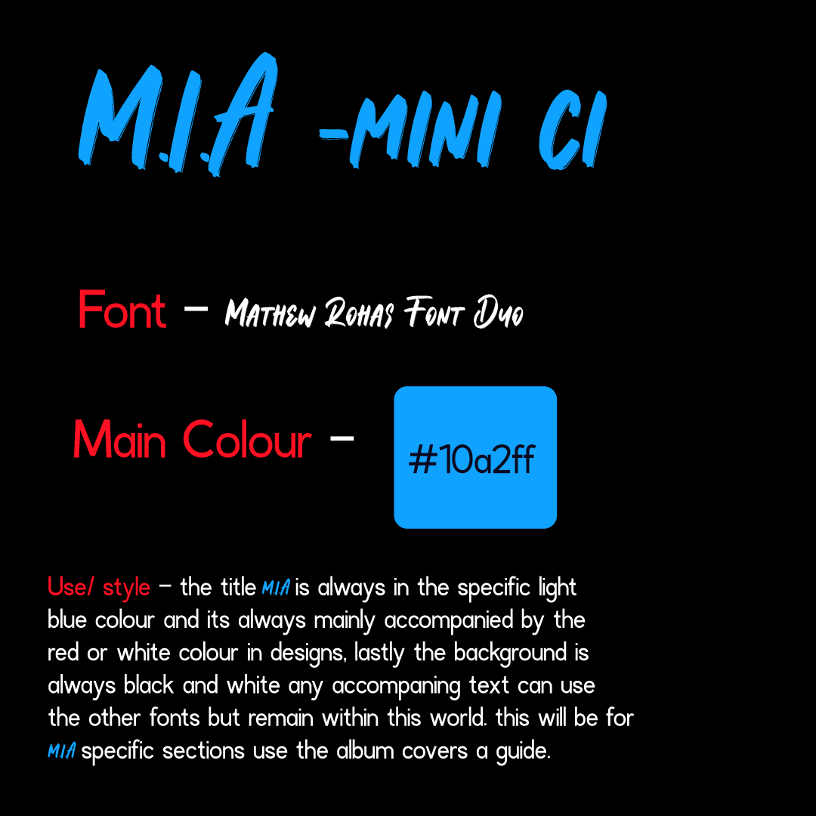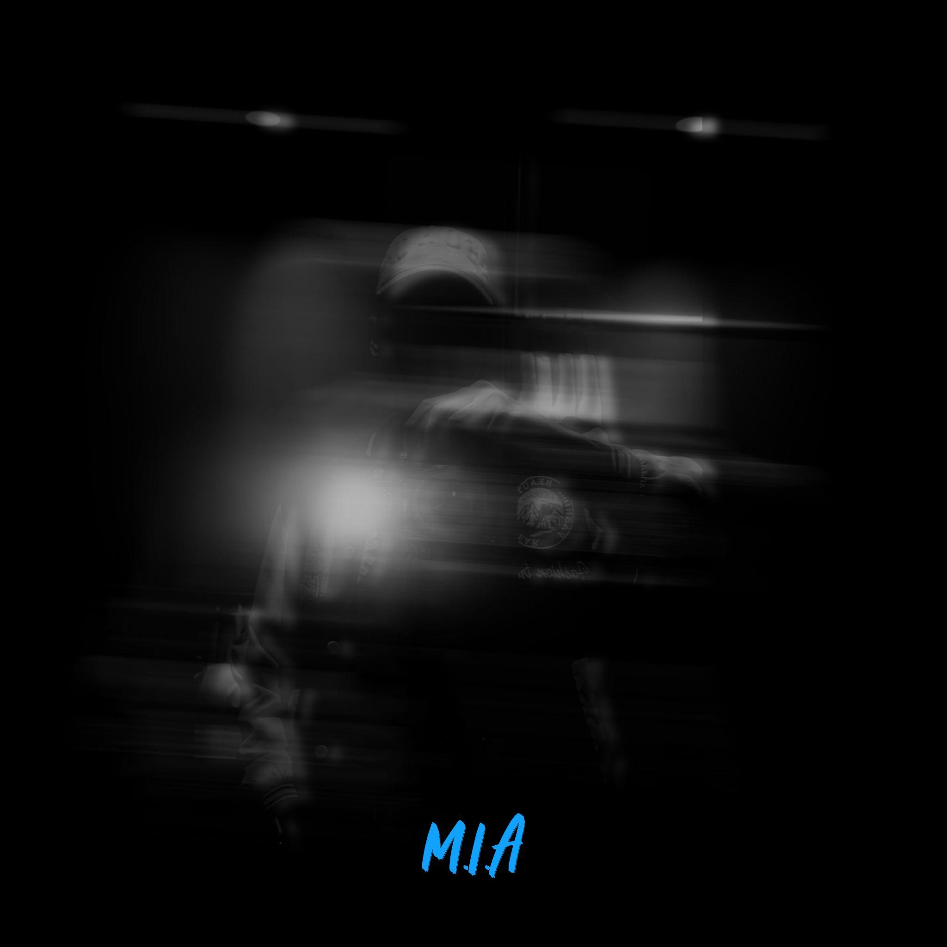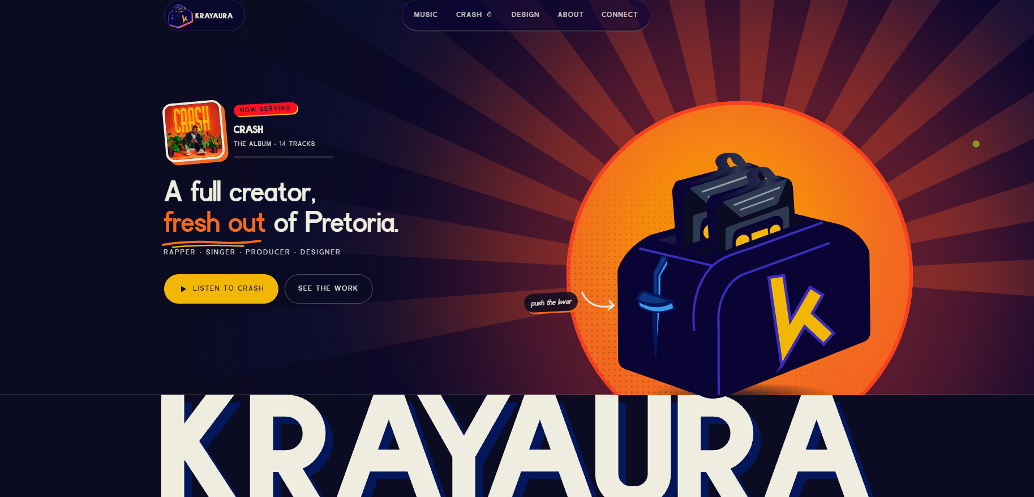

2. Music
Text update
Heading: WELCOME TO MY WORLD
Remember where we started?
Every record has a place in our story. Different sounds, different chapters, different versions of me.
What began with making beats grew into songwriting, producing, mixing vocals, rapping, singing, and creating worlds. Each release captures a moment in my journey and tells the story of the artist I am becoming.
Let's run it back and rediscover the journey behind Kray Aura.
ADDITIONS
For the Music section, honestly, everything is perfect apart from adding the new text. Once that's in place, all you'll need to do is add the new album and its cover art. I've included the album cover, so you can resize it as needed to fit the website.
One more thing: the album will be released on 5 November 2026. Since you're using a timeline to display the releases, I wanted to confirm the exact date so you can update it accordingly.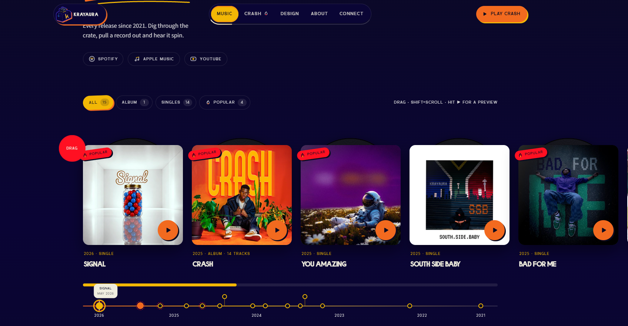

3. Visuals
TEXT
Heading: WATCH THE WORLD MOVE
Music videos, visualizers, behind-the-scenes moments, and everything in between. The music lets you hear me, but the visuals let you get to know me. Step into the worlds I create, get a feel for my style and vision, and see the process behind bringing it all to life.
Content sections:
- YouTube carousel
- Instagram pictures
- TikTok videos: breakdowns and process
Breakdown
I know the video section was originally part of the Music section, but I believe it deserves its own dedicated section. I've updated the text, so you'll just need to add the new copy.
In terms of the structure, I'd like to keep the existing YouTube carousel and, if possible, add two additional categories: Instagram pictures and TikTok videos. If this isn't feasible, that's completely fine.
1. YouTube
Keep the existing carousel.
2. Instagram
If possible, add a carousel or slideshow featuring selected pictures from my Instagram page. Feel free to choose whichever pictures you think work best for the website. I trust your judgment. Ideally, this section should also include a link to my Instagram page.
3. TikTok
If possible, add another carousel or slideshow featuring selected videos from my TikTok page. Again, feel free to choose whichever videos you think fit best.
For TikTok, I'd prefer videos where I'm talking to the camera, breaking down ideas, or creating music, such as making a beat. Most of my videos this year have been focused on those things, so there should be plenty to choose from.
I'd prefer not to use song snippets here, since the YouTube section already showcases my music videos.
The idea is to give each platform its own purpose: YouTube showcases the music videos, Instagram showcases the pictures, and TikTok showcases the process and the person behind the music. This way, visitors get to experience different sides of my creativity.
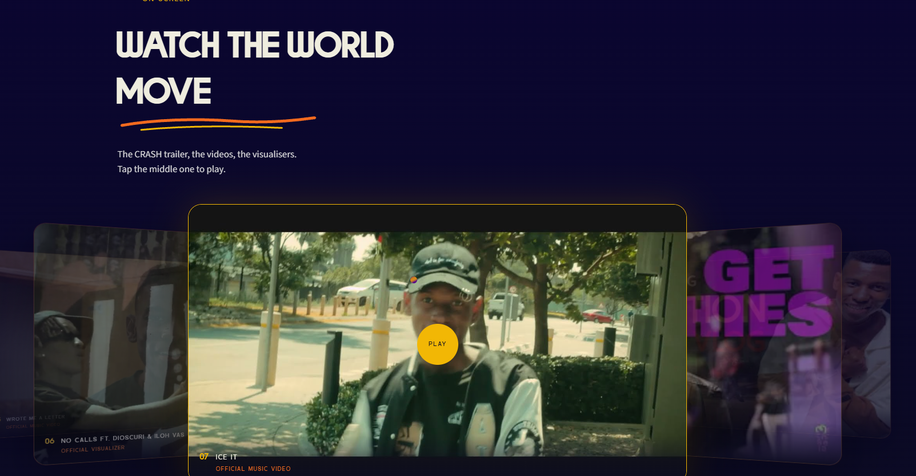

4. Albums
- M.I.A - Add this section and it should come first
- CRASH — The current section is perfect keep as is

Text for M.I.A
Imagine someone who's always been there suddenly becoming someone you can't reach. One day, everything's normal. The next, they're nowhere to be found. No explanation. No goodbye. Just silence.
You call. No answer. You text. Nothing. You start replaying every message, every conversation, every moment, wondering: Did I say something wrong? Did something happen? Why is he so distant? Is he avoiding me? The questions keep piling up. How does someone who's become part of your everyday life suddenly feel like a stranger?
Every song is a piece of the puzzle. The further you get into the album, the more the pieces come together. And slowly, what once made no sense starts to make sense.
If you've also been wondering where I've been, maybe it's time you found out.
Roll the dice. Press play. Find out for yourself.
ADDITIONS
As mentioned earlier, M.I.A. should appear first, followed by CRASH. The M.I.A. section should come before everything related to CRASH.
I'd like to keep a similar structure to what you created for CRASH, with the album cover on the left and the text on the right, but using the visual identity I provided for M.I.A.
M.I.A. visual direction:
- Colours: Black, white, and blue as the primary palette, with red as the only secondary accent colour when needed.
- Typography: The word “M.I.A.” should always use the specific font I provided.
- Text: Primarily white, with red used sparingly for secondary elements.
- Overall aesthetic: Darker, more minimal, and consistent with the M.I.A. creative identity.
I've included the Photoshop file, so feel free to experiment with the album cover and surrounding visuals to make the section look good while staying within the established theme.
I've also included the tracklist. You're welcome to incorporate it into the section if you think it works well, but it's not compulsory.
CRASH can retain its existing design and structure. It has a much brighter aesthetic, using sunshine as part of its visual direction, whereas M.I.A. has a darker tone. I'm really curious and excited to see how you'll interpret that difference while keeping both albums visually distinct.
Please also change the menu name and section heading from “CRASH” to “Albums”.
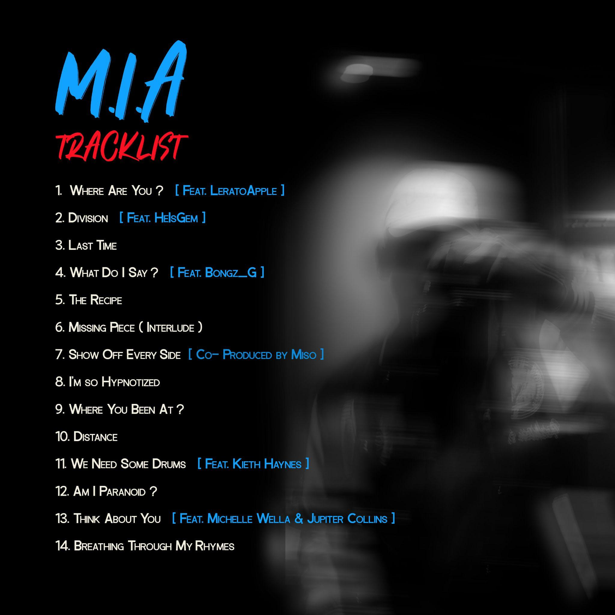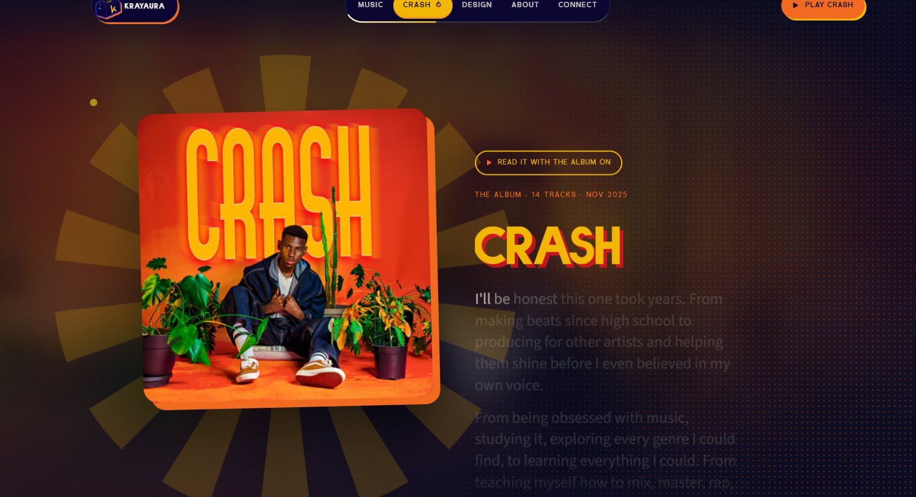

5. Design

Design Section
Honestly, I think the text and overall style are great. Keep “Visual Worlds with a Loud Personality” as the heading, but remove the description underneath it. I don't think it needs one, since the About section already goes deeper into my creative background.
I'd also like to simplify the section by removing the following:
- Channel World
- Cover Art
- Connected to the Future
These are either covered elsewhere on the website or already included in my school portfolio.
Instead, the Design section should feature just two portfolios, in this order:
1. Professional Portfolio
This should appear first. I'm still working on my professional portfolio, so it may grow over time. For now, let's use the version I've provided, as I believe it's strong enough to showcase my work. Later, I may provide an updated portfolio or a newly designed version.
You're welcome to write a short description for this portfolio.
2. School Portfolio
This should appear second. You can keep the existing description you wrote for it.
The buttons and the rest of the styling can remain as they are. I really like the overall design of this section.
One last thing: I initially wanted to remove orange from my colour identity, but the way you've incorporated it, especially alongside yellow, has made me appreciate its value. I actually like how it adds to the design, so I'm happy to keep it. Even though orange wasn't part of the original colour identity I provided, I think you've used it really effectively and I’m gonna bring it back into my CI thanks to you.
That's everything for the Design section!
One more addition to the Design section: since this is more work-focused, I'd like to keep the full Behance button and add a secondary Connect with Me button alongside it.
The idea is to make it easy for potential clients or anyone interested in working with me to get in touch directly.
Ideally, clicking Connect with Me should open a small menu with three options:
- Instagram: Take them directly to my Instagram DMs.
- Email: Open their email app with my email address ready to use.
- WhatsApp: Take them directly to my WhatsApp chat so they can message me.
If possible, I'd like all three options accessible through that one button. If that isn't practical, feel free to suggest an alternative that achieves the same goal.
The Behance button should remain unchanged, and the new button should complement it without disrupting the existing design and styling.
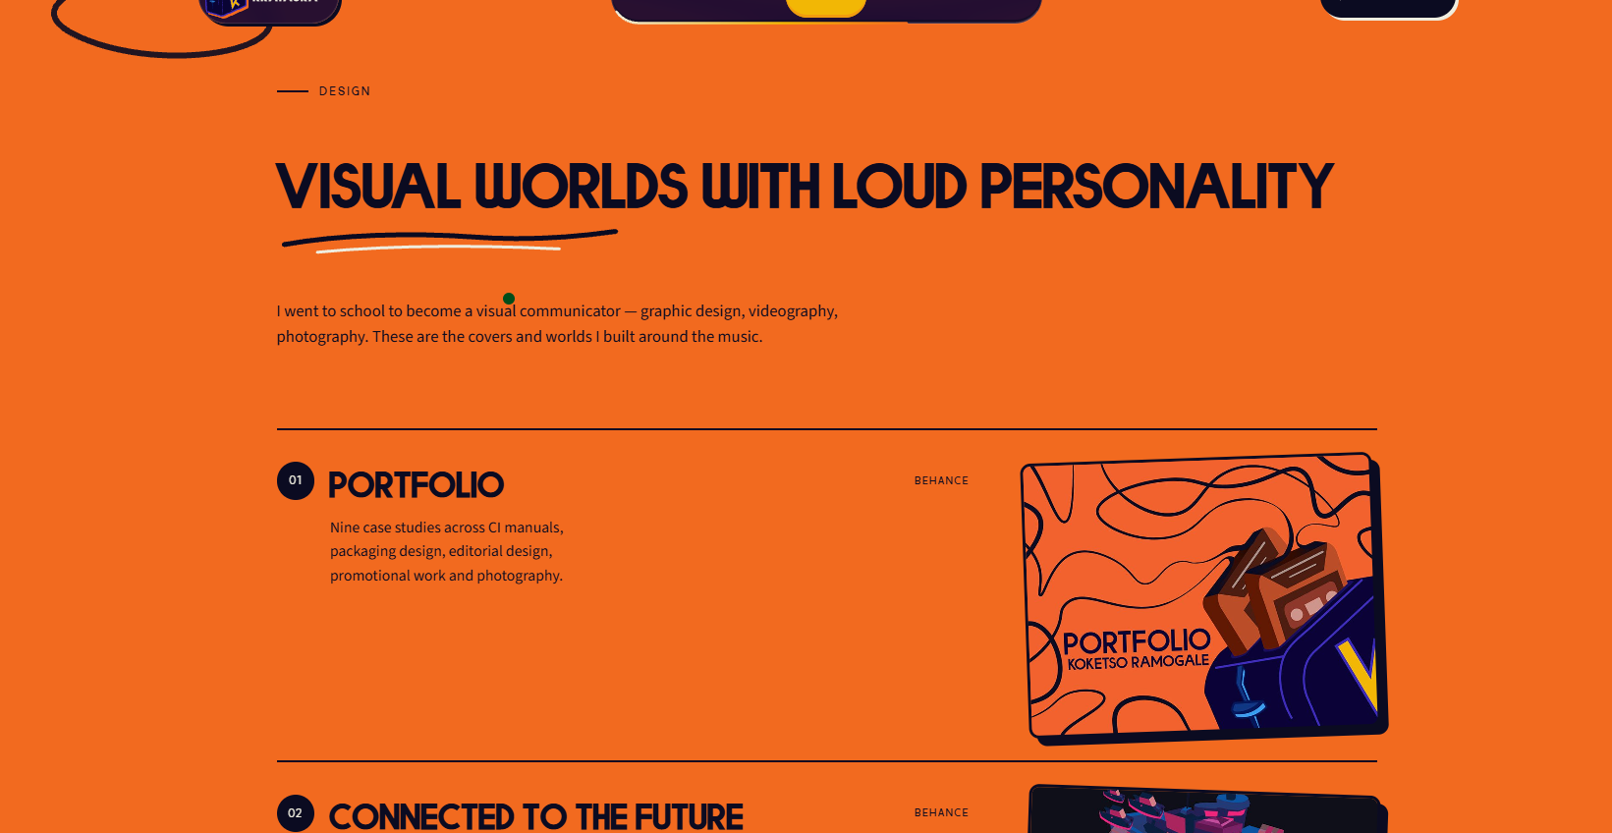
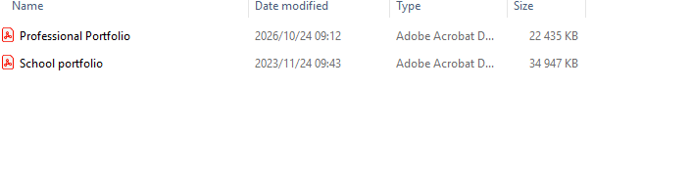

6. About

Gallery
- Add a gallery of 5 images i provided them
- Remove the “Based in Pretoria” sticker.
- Change the image section into a carousel.

Heading
DISCOVER THE ARTIST

Tags
- Rapper
- Singer
- Songwriter
- Music Producer
- Creative Director
- Graphic Designer
- Mixing & Mastering Engineer
- Motion Graphics Designer
- Web Designer
- Photographer & Videographer

Bio / Description (Replace the current bio you have with this)
I'm a South African artist combining music, design, and visual storytelling to create art that resonates with people, inspires new perspectives, and stays with them beyond the experience.
What started as making beats in high school set off a chain reaction that would shape my creative journey. Through YouTube, experimentation, and the resources available to me, I taught myself the many sides of music, from producing beats to writing, rapping, singing, and finding my sound.
Along the way, I studied graphic design at CTU Training Solutions, where I developed my understanding of visual communication and learned how to bring ideas to life visually. What began as two separate paths eventually became one creative world. Music shaped the way I approached design, and design changed the way I thought about music. Over time, the two became inseparable, each influencing how I create, express myself, and bring my ideas to life.
My creative influences are rooted in the music and pop culture of the 2000s and 2010s. Artists like Kanye West, Lil Wayne, Kendrick Lamar, Drake, and Travis Scott shape how I approach music and envision my identity as an artist. Beyond music, video games like GTA V, anime like Naruto, and franchises like Star Wars inspire my design sensibilities, drawing on the nostalgia and imagination of my childhood. Across both disciplines, I want to create work that sparks wonder and invites people to experience more than what's on the surface.
Through my work in design, I've created for brands and institutions including IMM Institute, Belgium Campus iTversity, IMM Graduate School, Open Window, University of Zambia, and Ticon Africa. In music, I've been releasing on platforms like Spotify and Apple Music since 2021, building my sound and artistic world through projects such as CRASH and M.I.A.
From producing and recording to developing music videos, I've grown through independent work and collaboration, guided by one principle: always remain a student of the game. I believe curiosity is one of my greatest strengths, pushing me to look beyond what I know, explore what something could become, and keep finding new ways to grow.
Simply put, I'm breathing through my art. Creativity is more than what I do; it's part of how I experience the world, express myself, and bring ideas to life. Whether through music, design, or visual storytelling, I use everything I've learned to tell my stories and help others tell theirs. As I continue to learn, create, and explore, my art remains a reflection of who I am and who I'm becoming.

Cassette Statistics
- 16 releases
- 2 albums
- Releasing since 2021
- 3 years of professional experience
- 2 design portfolios
- Designing since 2020

Quick addition to the About section: please remove “Based in Pretoria, South Africa” completely. I don't want my location displayed on the website.
You can replace it with either “Breathing Through My Art” or “Here's the Recipe” — choose whichever you feel fits the design and overall feel of the website best.

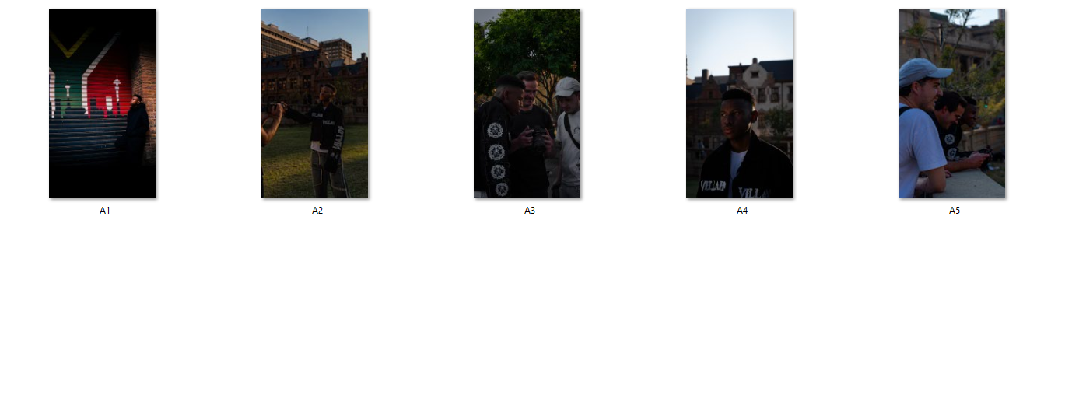
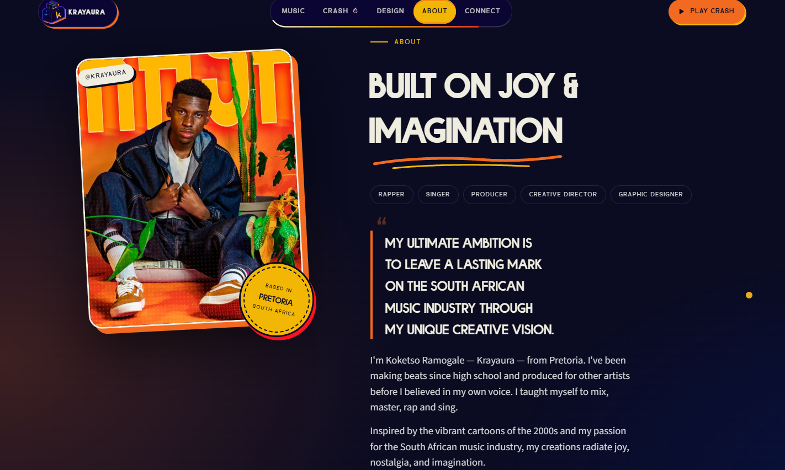
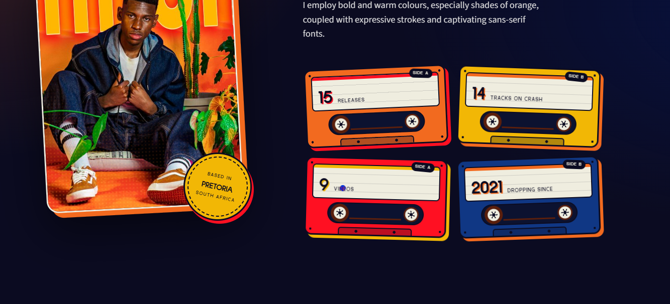

7. Connect
The final section, Connect, is almost perfect. Just a few final adjustments:
- Heading: Please change “Let's Cook Something Loud” to “Let's Cook Something” or “Let's Cook Something Crazy.” I really like “Let's Cook,” but I don't think “Loud” fits. Choose whichever of the two alternatives you feel works best with the website's overall identity.
- Supporting text: Instead of the current wording, let's use “Let's Connect” or “Press Here to Connect.” Choose whichever fits the design best.
- Contact button: Please remove “Book or Collab” and replace it with the new contact button we discussed. When clicked, it should ideally give visitors three options: Instagram DM, email, or WhatsApp, so they can contact me directly for bookings, features, collaborations, or other enquiries.
- Social links: Everything else in this section is perfect. All my social media and music links are there, so please keep them as they are.
- Linktree: Please remove the Linktree link entirely. The whole point of having my own website is to bring everything together in one place without needing Linktree.
That's everything for the Connect section. I'm happy with the rest of the design, so no other changes are needed here.
Contact details for the website
- Email: koketsoramogale04@gmail.com
- Phone / WhatsApp: 0826 680 2928
Please use these details to set up the contact options in the Connect section:
- Instagram DM: Opens my Instagram direct messages.
- Email: Opens the visitor's email app addressed to koketsoramogale04@gmail.com.
- WhatsApp: Opens a direct WhatsApp chat with me using 0826 680 2928.
Please make sure the email and WhatsApp options work when visitors click them.

